Daily
1.21
Approve the request from ChoWing’s modify readme

1.27
Approve the request from ChoWing’s upload contribution.md & proposal

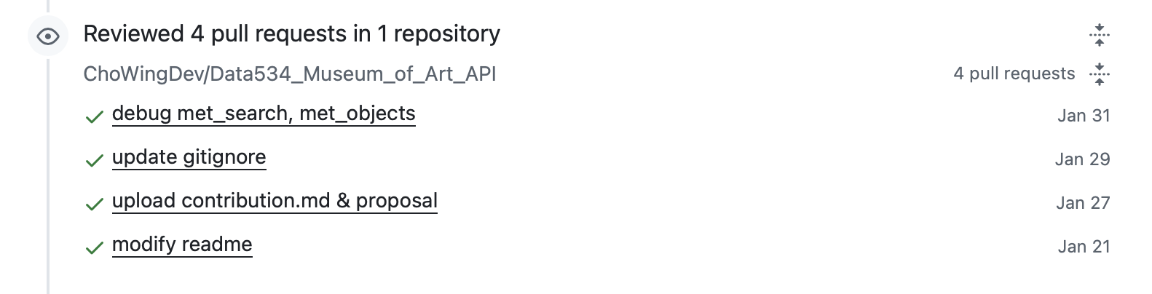

1.29
Approve the request from ChoWing’s update gitgnore

1.30
Create 3 commits in 1 repository
Opened the first pull request
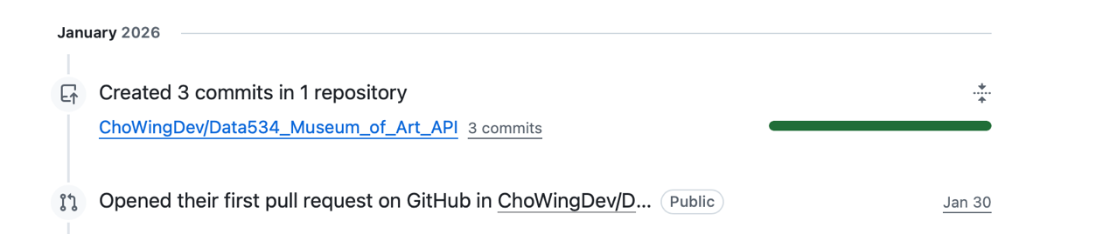
1.31
Approve the request from ChoWing’s debug met_search, met_objects
Done the vignette
Done the test
Passed the CI test
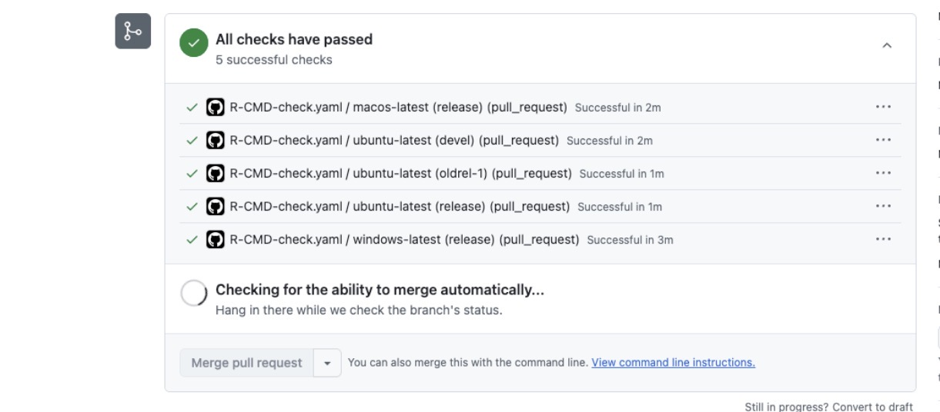
Request and Merged all

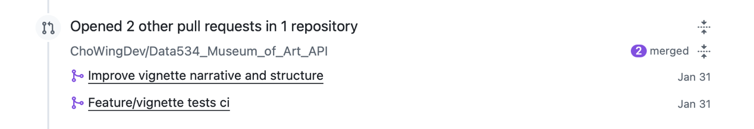

2.1
Create 3 commits in 1 repository
Reviewed 1 pull request about adding installation info to vignette
